~ GOSPEL REFLECTION ~
Immaculate Conception Parish

P O BOX 600 Tumut
Catholic Community
Collection amounts for January 2016 ~PARISH NEWS~
~ PARISH NEWS ~

Today’s feast of the transfiguration of Jesus is one of those gospel events that steps out of the ordinary as does, for example, the account of the baptism of Jesus by John. Both involve the presence of the divine and the divinely inspired. I think of the transfiguration as something like “coming attractions.” The event takes place near the end of Jesus’ public ministry and seems to act as a glimpse into the very near future -- Jesus’ death and resurrection.
Jesus leads three of his disciples, Peter, James and John into this special scene and then astounding events unfolded before their eyes: “he was transfigured” before them; his “face shone like the sun;” and his garments became “white like the light.” Peter responded by acknowledging “how good it is for us to be here.” And then the cloud, the ancient sign of the very presence of God overshadowed them, and the voice, “This is my beloved Son, listen to him.”
What on earth is going on here? From our historical perspective we can look back and say that the disciples were given a preview of the glory that belongs to Jesus after his death and resurrection and in the fullness of the Kingdom of God. They don’t know it now, but that is the same glory that they will be given after they bring the message of the Kingdom to their contemporaries.
What a special moment for them, and also for us who receive the promise of ultimate glory from Jesus through God’s generous love. We are invited to plumb the depths of this astonishing transfiguration moment in the lives of Jesus and the disciples.
I usually think of the “glory” of Jesus at the moment of the transfiguration being associated with his resurrection. But the truth is that BOTH the suffering/death of Jesus AND the resurrection represent to us the glory the Son has received from the Father.
An excerpt by Tom Shanahan S.J.

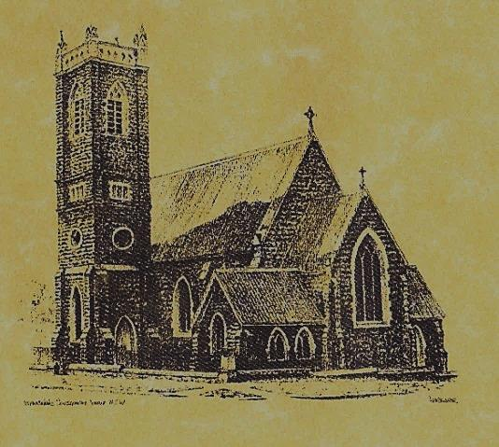

‘CLERGY’
- Fr. Sijo Jose (Parish Priest)
- Fr. Luke Verrell (Assistant Priest)

‘PARISH SECRETARY’
Anna Quinn
Phone: 02 69474599
Fax: 02 69474602
Email: tumut@cg.org.au
Web: www.cg.org.au/chancery
Office hours: Wednesday & Friday 9am -12noon
---------------------------------------------------------
‘WEEKEND MASS TIMES’
Saturday Vigil: 6.00pm
Sunday: 10am (Children’s Liturgy)

‘THIS WEEKS MASS TIMES’
Tuesday: 6pm
Wednesday: 10am (School Mass)
Thursday & Friday: 8am
Saturday: 9am (every fortnight - Thursday: 11am BUPA Liturgy
Saturday: 9.40am BLAKENEY LODGE Liturgy)
‘ROSARY’
Saturday at 8.45am
Exposition at 8.30am (1st Sat of month)
‘RECONCILIATION’
Saturday at 5.15pm
‘LITURGY MEETING’
Tuesday: 2.00pm in Chapel
‘PRAYER GROUP’
(Rosary & Divine Mercy)
Wednesday: 2pm in Chapel
‘CONTACTS’
Care Group: Anne Huebner 0406490415

The Transfiguration of the Lord
Year A
August 6th 2017

Entrance Antiphon
In a resplendent cloud the Holy Spirit appeared. The Father’s voice was heard: This is my beloved Son, with whom I am well pleased. Listen to him.

Responsorial Psalm
The Lord is king, the most high over all the earth.
Gospel Acclamation
Alleluia, alleluia! This is my Son, my beloved, in whom is all my delight; listen to him. Alleluia!

Gospel Acclamation
-----------------------------------
Alleluia, alleluia! Tomorrow the wickedness of the earth will be destroyed; the Saviour of the world will be our king. Alleluia!

T THIS WEEK Saturday & Sunday 5th & 6th August

Ministry | Saturday Vigil 6pm | Sunday 10am
Acolyte | Anita Masson | Dave Shedden
Reader | Christine Kelly | Howard Young
Commentator | Mary Kelly | Cathy Purcell
Children’s Liturgy | ---------- | Kerrin Henderson
Musicians | Patricia & Monica | Maureen Norman
Altar Servers | Jessie Raftery & Dana Parry | Xavier Henderson & Riley Hotham
Church Care  ________________________  LINEN Bev Piper | Group 2: Cathy, Anna, Pat Cheryl & Rhonda
NEXT WEEK Saturday & Sunday 12th & 13th August
Ministry | Vigil 6pm |  | 10am
Acolyte | Barry Madigan |  | Trish Matthews
Reader | Claire Cole |  | Pat Spannagle
Commentator | Shirley Kenny |  | John Power
Children’s Liturgy | ---------- |  | Fran Butler
Musicians | Maureen Norman |  | Patricia & Monica
Altar Servers | Gabbi & Maggi Dalisay |  | Abby Crampton & Olivia Dean
Church Care | Group 3: Yvonne, Lee, Mary, Colleen Kath & Brian
R O S T E R S
Feast Days

We pray for those who have gone before us marked with the sign of faith:

MASS HAS BEEN REQUESTED FOR:

Edward, Marcy & Clem Malone, Frank Stanfield, John Callister, Imelda, Bede & Francis McInerney, Teresa Butler, Joan Stockwell, Emmet Donovan, Rudi & Filomena Comai, Hassel McGrath, Noel Cook, Leo & Elvie Holt, Lionel & Tereasa Holt, Hugh Oliver, Pat Malone, Jim Whitaker, Matt & Edith Downing, Con & Ennis Twomey, Pauline Shedden, Bob & Sheila Wortes, Robert & Gertrude Tuncks, Ron & Pauline Hamilton, John Hourigan, Brian Gee, Alan & Angela Guthrie, Artie & Dulcie Piper, Tom, Kevin, Ruben & Harriett Arentz, Kevin Hawthorn, Kevin, Marie & Ray Cowan, Russell & Peter Ritchie, Alfred & Bridget Claffey, Ken Gee, Frederick & Mabel McInerney, Tom & Sam Sturt, Anna Do, Stan Kenny, Tom & Dorothy French and James Kelly.
8th August: Saint Mary of the Cross 10th August: Saint Lawrence 11th August: Saint Clare ~ ~ ~
We learn to see the face of Christ – the face of Christ that also is the face of a suffering human being, the face of the crucified, the face of the poor, the face of a saint, and the face of every person – and we love each one with the criteria with which we will be judge: ‘I was hungry and you gave me to eat.’ Archbishop Oscar Romero
~PARISH NEWS~
FEAST OF THE ASSUMPTION Mass will be at 10am on Tuesday August 15th instead of the evening Mass. PARISH STREET STALL will be held on Friday 18th August 2017 in front of House 2 Home. Helpers are needed to man the stall, if you can spare an hour, write your name on the roster in the church foyer or phone Tiffany on 0428239735. Donations of saleable items and home cooking will be much appreciated. Cash donations will also be greatly accepted. Please help make our stall a profitable one. CATHOLIC VOICE August edition is available for you to collect. BAPTISMS we welcome into our community this weekend Imogen Maree and Archie James daughter and son of Ewan & Vicki Watkins. We pray for baptism families. SAVE THE DATE ‘Marian Procession’ Sunday 8th October 2017. Archbishop Christopher extends an invitation to all Catholics of the Archdiocese of Canberra and Goulburn to attend the 2017 Marian Procession at St. Clement’s Monastery Galong. 9am: Youth Pilgrimage from Galong village. 10.30am: Confession 11.30am: Mass with Archbishop Christopher 12.30pm: Lunch 2pm: Procession to the grotto and sharing by Sr. Mary Rachel (OP). SPECIAL THANKS this weekend to Xavier & Riley – our new Altar Servers.

